Our Ref: MB/JC
July 2019

Dear Parents and Carers,
You will be aware that, as part of your child’s educational experience at Ian Ramsey Church of England Academy, we aim to promote personal wellbeing and development through a comprehensive taught programme of Personal, Social, Health and Economic (PSHE) education and Citizenship that gives young people the knowledge, understanding and practical skills to live healthy, safe, productive and fulfilled lives, both now and in the future.
As you may be aware, Relationships and Sexual Education (RSE) will be compulsory in all schools from September 2020. However, here at Ian Ramsey we have been fortunate to become an early adopter school. This means that we will be implementing the changes to our curriculum in September 2019. This will allow us to review and evaluate our curriculum so we are providing high quality provision to all our pupils before the statutory changes are implemented.
Our RSE lessons will be embedding throughout the curriculum and lessons will include students learning about healthy and unhealthy relationships, different types of families, managing online relationships, mental health and wellbeing, sexual orientation and gender identity, relationship/domestic abuse, child sexual exploitation and female genital mutilation. These are just a selection of the topics that we cover in Personal Development at Ian Ramsey Academy in preparation for our pupils living in an ever changing world.
Our Personal Development programme is taught throughout the school through year groups 7-10 and is monitored and reviewed by both the staff and the governing body. All teaching of Personal Development takes place in a safe learning environment and is underpinned by our school ethos and values. A variety of opportunities will be provided for students to ask questions in order to prepare them for relationships in the modern world.
As a school community, we are committed to working in partnership with parents and want to keep you updated with the changes going on in school that will have an impact on not only your child’s education but on their life outside the academy as we endeavour to keep the student’s happy, successful and safe throughout their lives.
If you would like to find out more or discuss any concerns, please do not hesitate to contact me at barkerm@ianramsey.org.uk.
Yours sincerely,
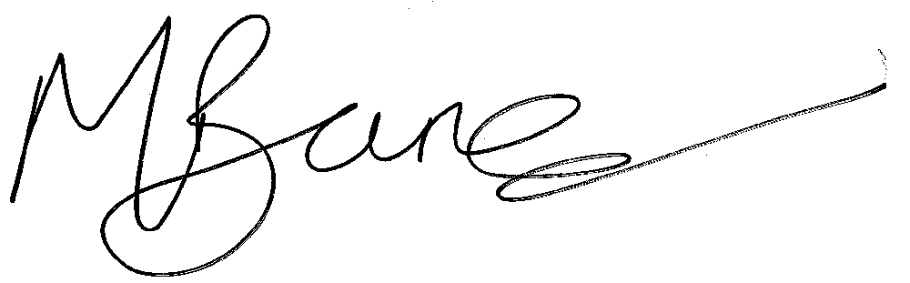
Michelle Barker
PD - Coordinator

