Dear Parent/Carer,

Below are a number of key messages that we need to share as we look forward to the new academic year, in September 2019.

1. **Timings of the school day**

Our new year 7s will start on Wednesday 4th September at 8.35am but **all other year groups need to arrive for 11.00am** that day. Below are the new timings of the school day from next term.

8.35 am All pupils must be in school

8.40 am Collective worship and registration

9.00 am Period 1 for all pupils

10.00 am Break time Y7, 8, 10 Period 2 Y9/11

10.15 am Period 2 Y7, 8, 10

11.00 am Break time Y9/11

11.15 am Period 3 all pupils

12.15 pm Lunch time Y8/10 Period 4 Y7, 9 & 11

12.45 pm Lunch time Y7 Period 4 Y8/10

1.15 pm Lunch time Y9/11 Period 4 Y7, 8 & 10

1.45 pm Period 5 all pupils

2.45 pm End of school day all pupils

1. **ClassCharts**

Class Charts is an online system which teachers use to track achievement and behaviour throughout the school day. We believe in working closely with parents and, one of the key benefits of using Class Charts is, that we are able to securely share your child(s) achievement and behaviour report with you and so, keep you up to date in real-time.

Each child has a unique access code which is issued to carers.

Once you have been issued with a code, you will need to create an account and enter the code here:

<https://www.classcharts.com/parent/login>

Links to mobile phone apps are also available to parents from this page.

If you have more than one child in the school then you can enter additional codes once you have created an account and are logged in. Please do get in touch if you have any questions.

**Uniform**

All items of uniform are available from Elizabeth’s Embroidery, Richardson Road, Stockton (price list attached). Items listed below as “Academy…” are only available for purchase from Elizabeth’s Embroidery. We recommend that you put your child’s name in all items of uniform and PE kit.

[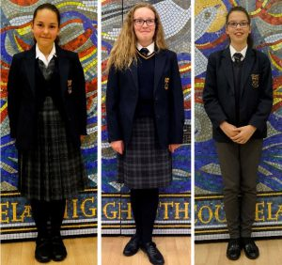](https://ianramsey.org.uk/wp-content/uploads/2018/06/uniformgirls.jpg)**Girls Uniform**

Compulsory

* Academy blazer with badge

Choose from:

* Academy four button pleated kilt (must reach

below the knee)

* Academy pinafore (must reach below the knee)
* Charcoal grey trousers (not skinny fit or lycra)

And choose from:

* White collared shirt and academy tie
* Academy blouse with logo on the collar

Optional

* Academy knitted jumper
* Academy knitted tank top
* Academy knitted cardigan

[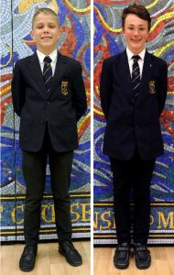](https://ianramsey.org.uk/wp-content/uploads/2018/06/uniformboys.jpg)**Boys Uniform**

Compulsory

* Academy blazer with badge
* White collared shirt with academy tie
* Charcoal grey trousers (not skinny fit)

Optional

* Academy knitted jumper
* Academy knitted tank top

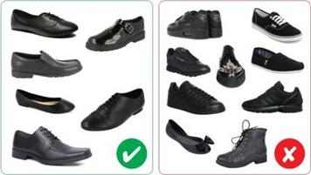**Shoes**

Only plain black leather or leather-look shoes

are allowed to be worn with the uniform. No

trainers, boots, pumps or canvas/fabric/suede

shoes will be allowed. Fashion shoes or trainers

such as Ted Baker/Nike/Vivienne Westwood

are **not** appropriate.

**PE Uniform**

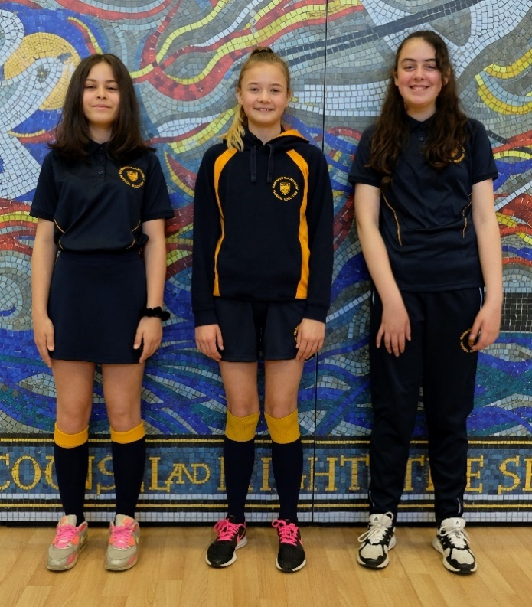

**Girls Uniform**

Compulsory

* Academy polo shirt
* Academy socks
* Trainers

Choose from:

* Academy tracksuit bottoms
* Academy leggings

And choose from:

* Academy hoody
* Academy sports jacket

Optional

* Academy skort
* Academy shorts
* Academy Base Layer

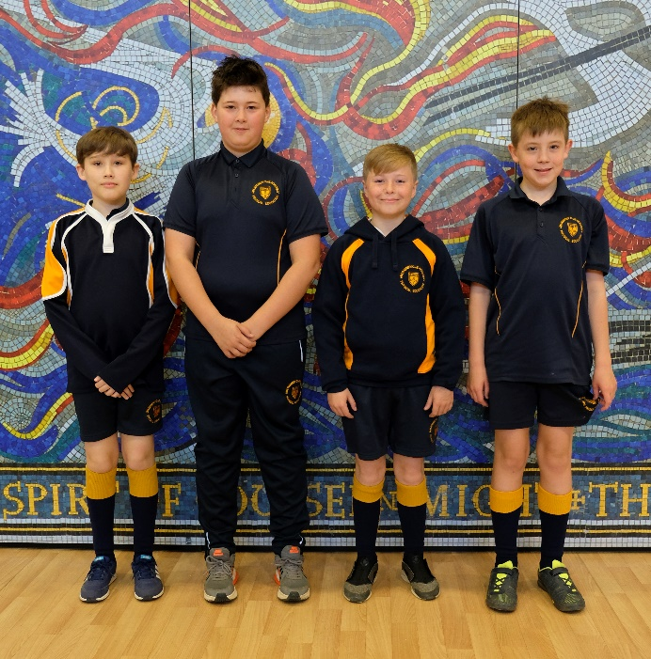**Boys Uniform**

Compulsory

* Academy rugby shirt
* Academy t-shirt
* Academy shorts
* Academy socks
* Trainers
* Football boots

Optional

* Academy hoody
* Academy sports jacket
* Academy Base Layer

I would like to thank you for your support in helping to raise standards at Ian Ramsey Church of England Academy over the last academic year.

To avoid any confusion or misinterpretation, you have asked if we can publish clear guidelines for acceptable standards of uniform from September. All pupils have been reminded of these expectations in standards assemblies. We welcome your support in ensuring your son/daughter conforms to these requirements:

* Equipment – pupils will require a bag big enough to carry their equipment and school books. They are expected to bring 2 pens, a pencil and a ruler. Pupils in Years 7 and 8 are also expected to bring a reading book to school.
* Jewellery – **one pair of small studs** (to be worn in their earlobes) and a wristwatch. Other jewellery is unacceptable and pupils will be asked to remove it. The school does not accept any responsibility for the loss of jewellery.
* Smart watches and bluetooth headphones are not to be brought into the academy.
* Make-up – pupils in Year **9, 10 and 11** **only** may wear minimal, natural foundation. Pencilled in eyebrows, tattooed eyebrows, false eyelashes, acrylic nails, gel nails, nail varnish, contouring, bronzer, blusher etc. are **NOT** acceptable and pupils will required to remove them. Fake tan is not permitted. Make-up will be confiscated from pupils if it is brought into the academy.
* From September 2019, every pupil in Y7-11 will be issued with a locker and any mobile phones must be switched off and locked away before our morning collective worship at 8:40am. Pupils will then collect their devices at the end of the school day. Pupils can only start to use their devices once they have left the ‘front’ academy gates. Any devices seen out, in the school building or grounds at any time, will be confiscated and locked in the school safe. Refusal to hand over the device could result in a fixed term exclusion. Parents/Carers will have to attend the academy themselves to collect the device(s). The Head teacher retains the right to ban a pupil from bringing a mobile phone onto the premises for repeated offences.
* Hairstyles – pupils are only permitted to have natural hair colours and no extreme or unnatural colours are allowed. Hair styles must not be extreme and lines and patterns cannot be shaved in hair or eyebrows.
* Energy drinks or fizzy drinks are not allowed and will be confiscated and disposed of.
* Large amounts of sweets, biscuits, chocolate etc. are not permitted in the academy and will be confiscated and disposed of. Chewing gum is not permitted in the academy.
* We recommend roll-on or stick deodorants, as aerosols are also not allowed in the academy due to the sensitivity of the fire alarms. Any found will be confiscated and returned at the end of the day.

Finally, I would like to thank you for your continued support, as we work in partnership, to provide the best possible secondary school experience for our children. We hope you have a safe and enjoyable summer with your family and friends and look forward to welcoming the children back to Ian Ramsey in September 2019.

Best wishes,

B Janes-Small

Mr B. Janes (Head Teacher)