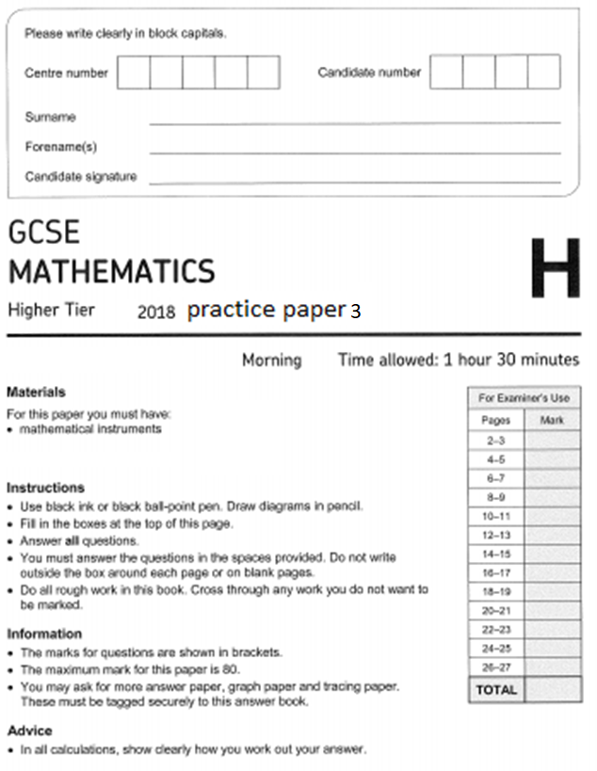
1 The formula $A=πr^{2}$ is rearranged to make r the subject. Circle the correct rearrangement.
[1 mark]
$r=\sqrt{\frac{A}{π}}$ $r=\sqrt{\frac{π}{A}}$ $r= πA^{2}$ $r=Aπ^{2}$

2 y is directly proportional to x. Circle the graph that shows this relationship.
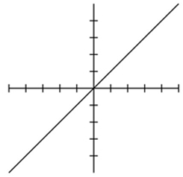
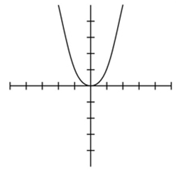
[1 mark]
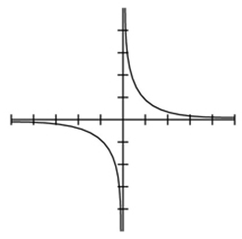
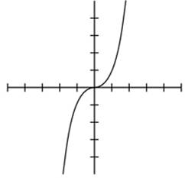

3 Circle the reason that triangles ABC and PQR are congruent.
[1 mark]
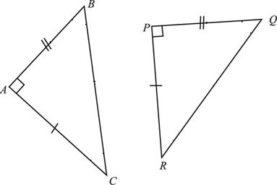
SSS SAS ASA RHS

4 1 kilogram ≈ 2.2 pounds
1 pound = 16 ounces.
Circle the number of ounces in a kilogram.
[1 mark]
35.2 7.27 32.32 137.5

5 Calculate the volume of the 3D shape below.
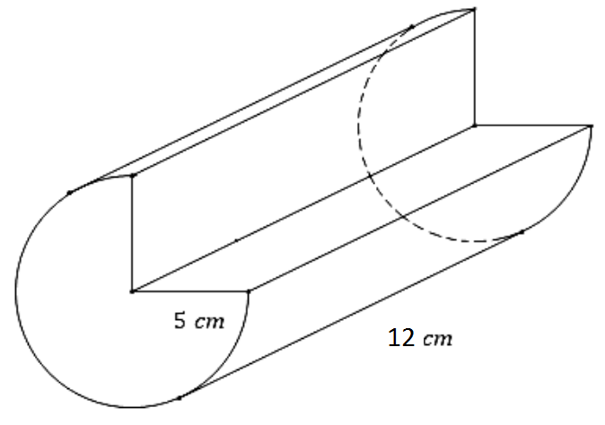
[3 marks]
Answer

6 Linda recorded the temperature, in ºC, at 7 am on each of 30 days.
The table shows information about here results.
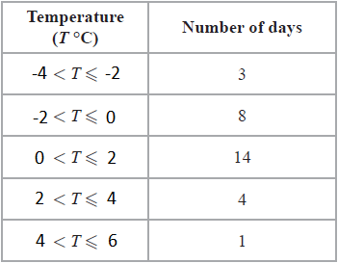
Calculate an estimate for the mean temperature.
[3 marks]
Answer

7
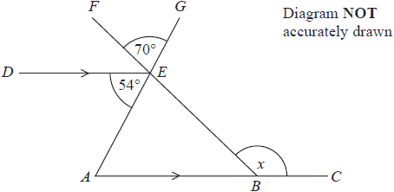
ABC and DE are parallel lines.
AEG and BEF are straight lines.
Angle AED = 54°
Angle FEG = 70°
Work out the size of the angle marked x.
Give a reason for each stage of your working.

[4 marks]
Answer

8 (a) Complete the table of values for $y=x^{2}-2$
[2 marks]
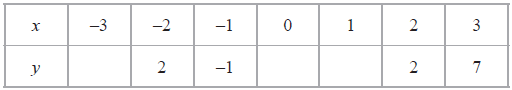

8 (b) On the grid, draw the graph of $y=x^{2}-2$ for values of x from -3 to 3
[2 marks]
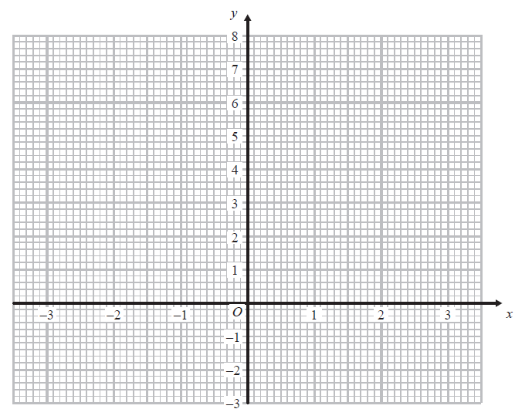

9 Gary drove from London to Sheffield. It took him 3 hours at an average speed of 80km/h.
Lyn drove from London to Sheffield.
She took 5 hours.
Assuming that Lyn
drove along the same roads as Gary
and did not take a break,
9(a) Work out Lyn's average speed from London to Sheffield.
[3 marks]
Answer

9(b) If Lyn did not drive along the same roads as Gary, explain how this could affect your answer to part (a).
[1 mark]

10 Harry has a cable.
The cable has a length of 16 metres.
Harry cuts the cable into two parts, part A and part B.
The length of part A is 5 metres.
The weight of part A is 8 kg.
Work out the weight of part B.
[3 marks]
Answer

11 Solve the equation $\frac{5w-8}{3}=4w+2$
[3 marks]
Answer

12 Expand $(3x-2)(2x+1)(x-5)$
[3 marks]
Answer

13 Here are the first four terms of a quadratic sequence.
3 8 15 24
13(a) Find an expression, in terms of n, for the nth term of this sequence.
[3 marks]
Answer

The nth term of a different sequence is 2^{n} + 5
13(b) Show that 36 is not a term of this sequence.
[1 mark]

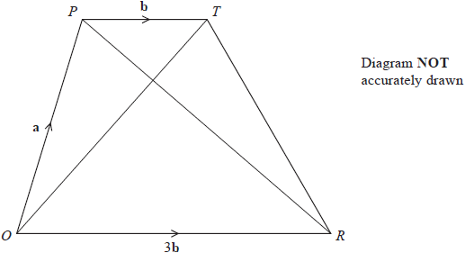
14

OPTR is a trapezium.

$$\vec{OP}=a$$
$$\vec{PT}=b$$
$$\vec{OR}=3b$$

14(a)(i) Find $\vec{OT}$ in terms of a and b
[1 mark]
Answer

14(a)(ii) Find in terms of a and b
Give your answer in its simplest form.
[1 mark]
Answer

S is the point on PR such that PS : SR = 1 : 3

14(b) Find in terms of a and b
Give your answer in its simplest form.
[2 marks]
Answer

14(c) What does your answer to part (b) tell you about the position of point S?
[2 marks]

15 A café owner sells 10 different types of sandwich.
Rayheem buys a different type of sandwich on Monday, on Tuesday and on Wednesday.
In how many ways can he do this? Circle the correct answer.
[1 mark]
1000 30 720 27

16 f and g are functions such that
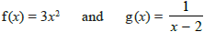
Circle gf(4).
[1 mark]

$\frac{1}{4}$ $\frac{1}{142}$ $8$ $\frac{1}{46}$
17 Write $\sqrt[3]{\frac{1}{625}}$ as a power of 5. Circle the correct answer.
[1 mark]
$5^{-\frac{4}{3}}$ $5^{-\frac{3}{4}}$ $5^{-12}$ $5^{-\frac{3}{125}}$

18 Circle the correct expression for the area of this triangle.

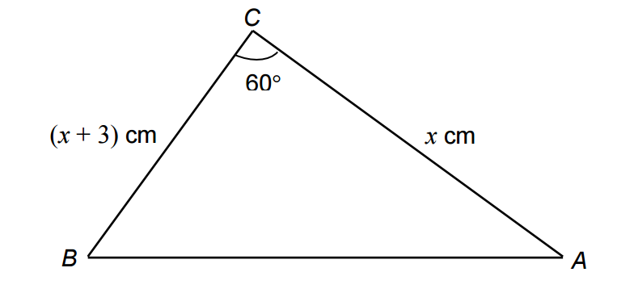

$\frac{1}{2}x(x+3)$ $\frac{\sqrt{3}x(x+3)}{2}$ $60x(x+3)$ $\sqrt{3}x(x+3)$

19 There are only n red balls and (n + 1) blue balls in a bag.
Shamsa takes at random 2 balls from the bag.
Show that the probability that both balls are the same colour is $\frac{n}{2n+1}$.
[4 marks]

20 The table and the histogram show some information about the time, in minutes, taken by a group of students to travel to college in one week.
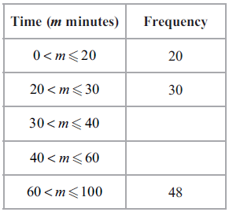
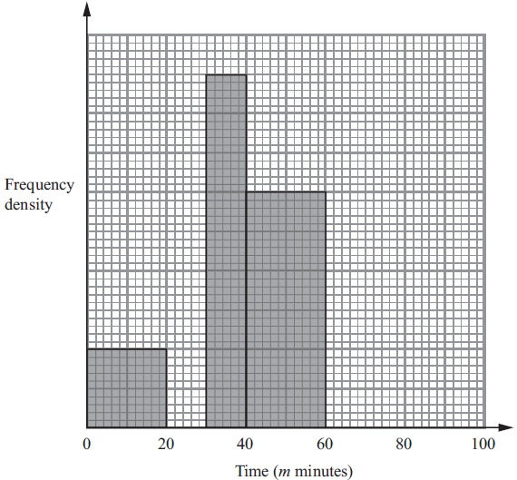

20(a) Use the histogram to complete the table.
[2 marks]

20(b) Use the table to complete the histogram.
[2 marks]

20(c) Work out an estimate for the median time.
[2 marks]
Answer

21 VABCD is a solid pyramid.
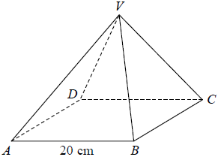

ABCD is a square of side 20 cm.
The angle between any sloping edge and the plane ABCD is 55°
Calculate the surface area of the pyramid.
Give your answer correct to 2 significant figures.
[4 marks]
Answer

22 The expression x² – 8x + 21 can be written in the form (x – a)² + b for all values of x.

22(a) Find the value of a and the value of b.
[2 marks]
Answer | a = | b =

The equation of a curve is y = f(x) where f(x) = x² – 8x + 21
The diagram shows part of a sketch of the graph of y = f(x).
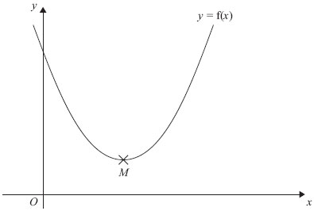

The minimum point of the curve is M.
22(b) Write down the coordinates of M.

Answer | ( , | )

23 A frustum is made by removing a small cone from a large cone as shown in the diagram.
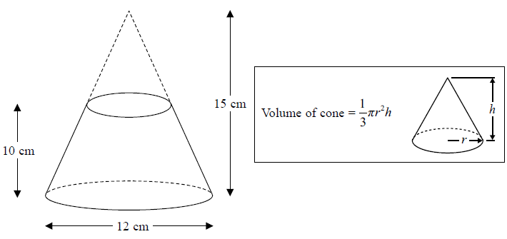
Work out the volume of the frustum.
Give your answer to an appropriate degree of accuracy.

[4 marks]
Answer

24(a) Show that the equation x³ + 4x = 1 has a solution between x = 0 and x = 1
[2 marks]
24(b) Show that the equation x³ + 4x = 1 can be arranged to give $x=\frac{1}{4}-\frac{x^{3}}{4}$

[1 mark]

24(c) Starting with x_{o} = 0, use the iteration formula $x_{n+1}=\frac{1}{4}-\frac{{x_{n}}^{3}}{4}$ twice, to find an estimate for the solution of x³ + 4x = 1
[3 marks]
Answer

26 For any three consecutive whole numbers, prove algebraically that
the largest number and the smallest number are factors of the number that is one less than the square of the middle number.
[3 marks]

27 On the grid, shade the region that satisfies all these inequalities.
y > 1 x + y < 5 y > 2x
Label the region R.
[3 marks]

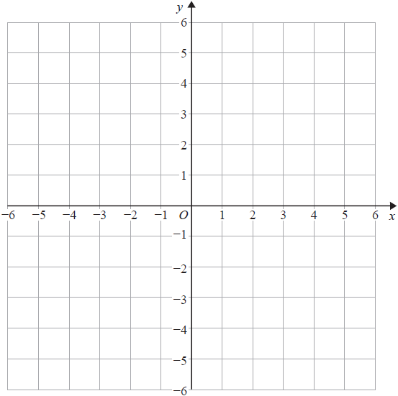
28 Here is a speed-time graph showing the speed, in metres per second, of an object t seconds after it started to move.
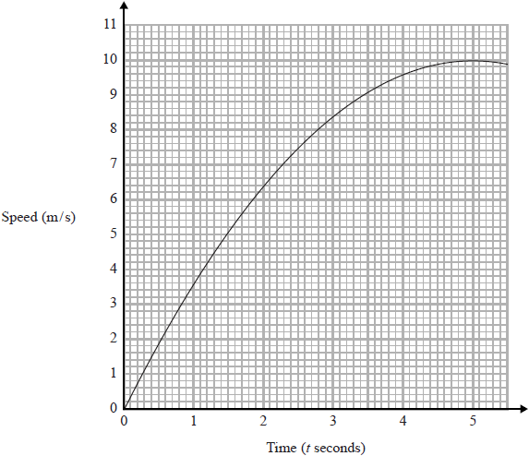
28(a) Use 3 strips of equal width to find an estimate for the area under the graph between t = 1 and t = 4
[3 marks]
Answer

28(b) Describe fully what your answer to part (a) represents.
[2 marks]

28(c) Estimate the acceleration of the object after 4 second.
[2 marks]
Answer

