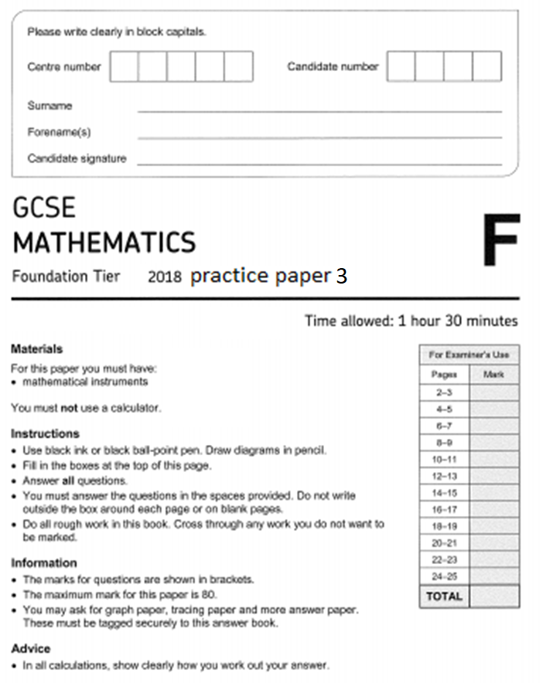
1 Circle the smallest number in this list:

-4 × 2 -2 + -5 (16 ÷ -4) –3 – 6
[1 mark]

2 Circle the value of 3.645 rounded to 1 decimal place:

3.7 3.6 4 3.65
[1 mark]

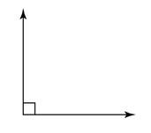
3 Circle the reflex angle:
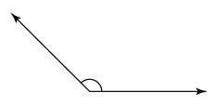
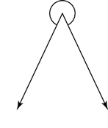
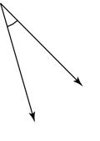

[1 mark]
4 Circle the multiple of 8:
4 52 56 60
[1 mark]

5 Here is a list of the names of five types of quadrilateral.
Trapezium Parallelogram Square Rhombus Rectangle
5 (a) From the list, write down the names of two quadrilaterals which must have all four sides the same length.
[1 mark]
Answer |  | &

5(b) From the list, write down the name of the quadrilateral that has only one pair of parallel sides.
[1 mark]
Answer

6 The probability of an event is shown by the cross (×) on the probability scale.
Write down an estimate for the probability of the event.
[1 mark]
Answer

7 Complete this bill

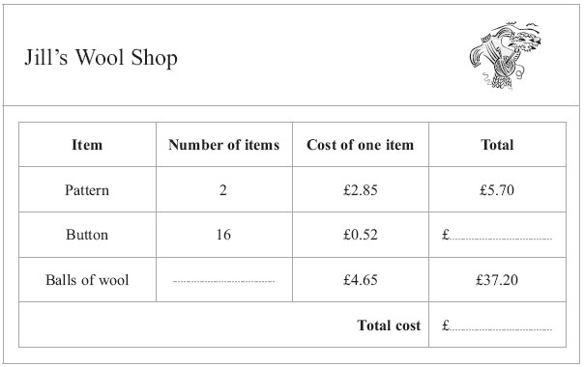

[3 marks]

8 The table shows the number of TVs sold in a shop on each of five days.
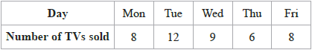
David uses this information to draw the graph below.
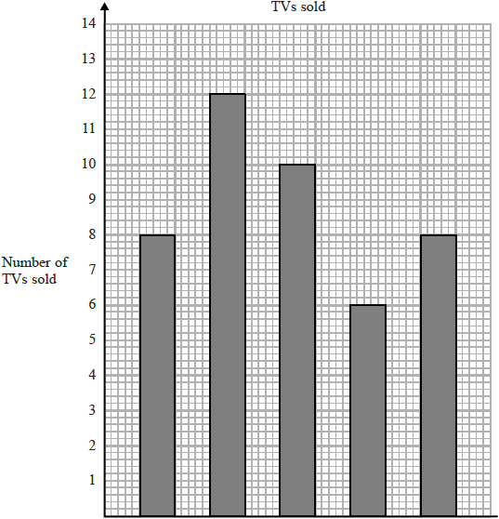
Write down three things wrong with this graph.
[3 marks]
1
2

3

9 Increase $26\frac{1}{2}$ by $\frac{3}{4}$.
[3 marks]
Answer

10 Here is a sequence of patterns made with counters.
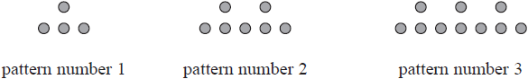

10 (a) Find an expression, in terms of n, for the number of counters in pattern number n.

[2 marks]
Answer

Bayo has 90 counters.
10 (b) Can Bayo make a pattern in this sequence using all 90 of his counters?
You must show how you get your answer.
[2 marks]
Answer

11 In a tin of baked beans,
weight of beans : weight of tomatoes : weight of other ingredients = 3 : 2 : 1
There are 150 g of tomatoes in the tin.
Work out the weight of the beans.
[2 marks]
Answer

12
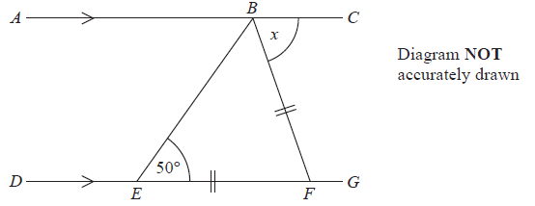
ABC is a straight line.
DEFG is a straight line.
AC is parallel to DG.
EF = BF.
Angle BEF = 50°.
Work out the size of the angle marked x.
Give reasons for your answer.
[4 marks]
Answer
13 Balena has a garden in the shape of a circle of radius 10 m.
He is going to cover the garden with grass seed to make a lawn.
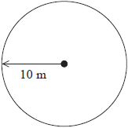
Grass seed is sold in boxes.
Each box of grass seed will cover 46 m² of garden.
Balena wants to cover all the garden with grass seed.
Work out the number of boxes of grass seed Balena needs.
You must show your working.
[4 marks]
Answer

14 100 students had some homework.
42 of these students are boys.
8 of the 100 students did not do their homework.
53 of the girls did do their homework.
14(a) Use this information to complete the frequency tree.
[3 marks]

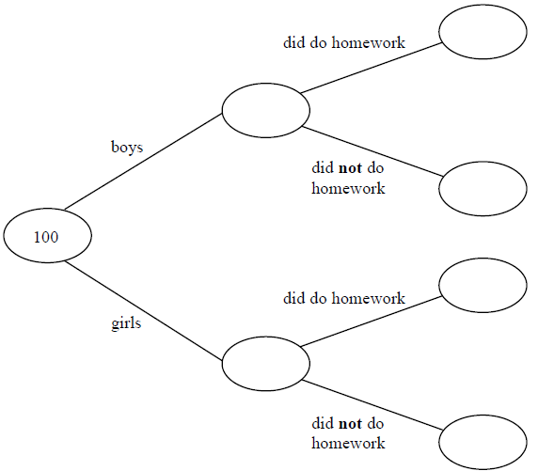

One of the girls is chosen at random.
14(b) Work out the probability that this girl did not do her homework.
[2 marks]
Answer

15 The table gives information about the results of the matches a football team played.
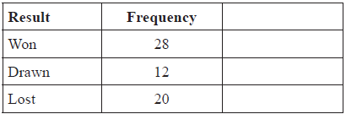
Draw an accurate pie chart to show this information.
[4 marks]

16 In a sale, the price of a cooker is reduced by 50%
At the end of the sale, the sale price of the cooker is increased by 50%
Betty says,
"The cooker is now the same price as it was before the sale."
Is Betty correct?
Explain why.
[2 marks]

17 The formula $A=πr^{2}$ is rearranged to make r the subject. Circle the correct rearrangement.
[1 mark]
$r=\sqrt{\frac{A}{π}}$ $r=\sqrt{\frac{π}{A}}$ $r= πA^{2}$ $r=Aπ^{2}$

18 y is directly proportional to x. Circle the graph that shows this relationship.
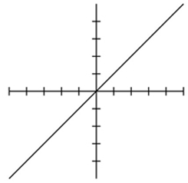
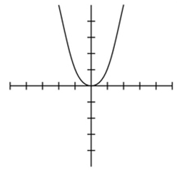
[1 mark]
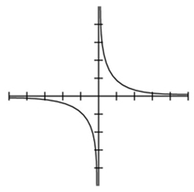
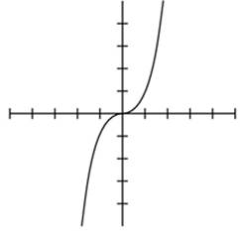

19 Circle the reason that triangles ABC and PQR are congruent.
[1 mark]
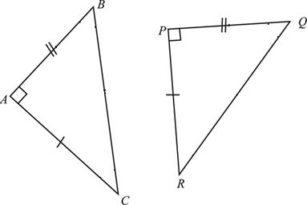
SSS SAS ASA RHS

20 1 kilogram ≈ 2.2 pounds
1 pound = 16 ounces.
Circle the number of ounces in a kilogram.
[1 mark]
35.2 7.27 32.32 137.5

21 Calculate the volume of the 3D shape below.
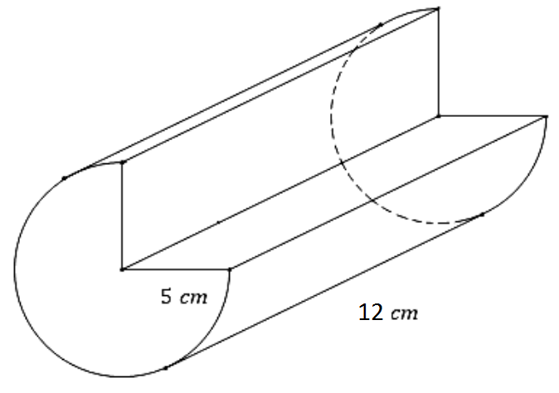
[3 marks]
Answer
22 Linda recorded the temperature, in ºC, at 7 am on each of 30 days.
The table shows information about here results.
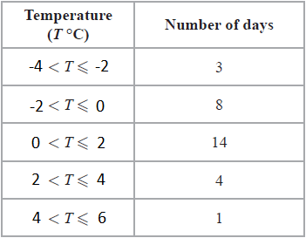
Calculate an estimate for the mean temperature.
[3 marks]
Answer

23
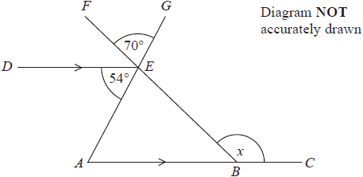
ABC and DE are parallel lines.
AEG and BEF are straight lines.
Angle AED = 54°
Angle FEG = 70°
Work out the size of the angle marked x.
Give a reason for each stage of your working.

[4 marks]
Answer

24 (a) Complete the table of values for $y=x^{2}-2$
[2 marks]
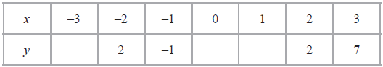

24(b) On the grid, draw the graph of $y=x^{2}-2$ for values of x from -3 to 3
[2 marks]
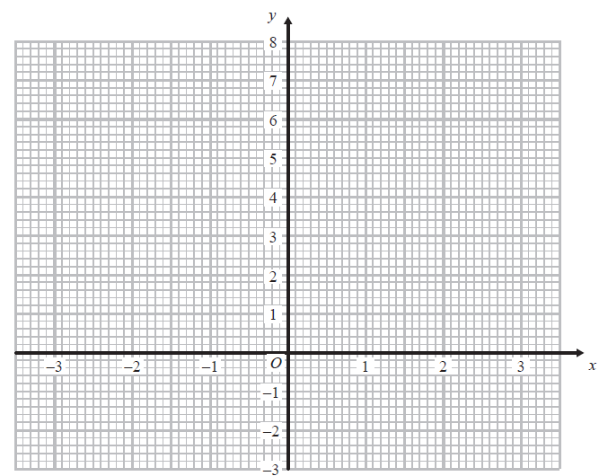

25 Gary drove from London to Sheffield. It took him 3 hours at an average speed of 80km/h.
Lyn drove from London to Sheffield.
She took 5 hours.
Assuming that Lyn
drove along the same roads as Gary
and did not take a break,
25(a) Work out Lyn's average speed from London to Sheffield.
[3 marks]
Answer

25(b) If Lyn did not drive along the same roads as Gary, explain how this could affect your answer to part (a).
[1 mark]

